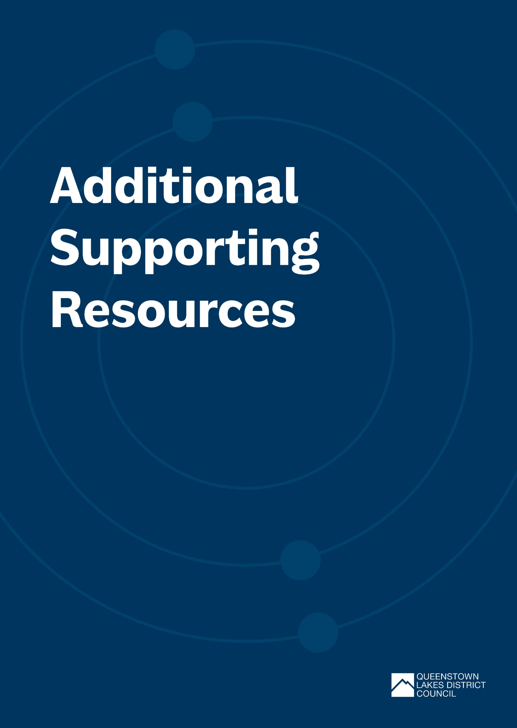

Additional Supporting Resources
Waste Resources
At events - Plastic Free July | Tips to reduce waste at events
Choosing a Safe and Sustainable Reusable Serviceware Fleet | A report commissioned by Takeaway Throwaways to support groups in Aotearoa New Zealand who are establishing reusable serveware systems to procure the most sustainable and safe reusable serveware fleets possible.
Let’s talk rubbish: the videos | beyond the bin | Beyond the Bins Practical Guide to Event Waste Minimisation. Resources include short guidance videos and free planning resources.
Library — Takeaway Throwaways | Reusable serveware systems and the policy changes needed to support their growth can be complex. Takeaway Throwaways is committed to creating and commissioning resources to help communities, businesses and policymakers to get best-practice reuse systems off the ground. This page is where you’ll find those resources.
Plastic Free Wanaka | Waste free shopping guide and SUCfree resources.
Reusable-serviceware-at-markets-December-2023.pdf (reuseaotearoa.org.nz) | Reusable serveware/packaging at markets (& events) in Aotearoa New Zealand information sheet.
Takeaway Throwaways | A campaign and resource library centred on reuse.
WasteMINZ zero waste events guidance | Guidance for creating signage for zero waste events.  Agreed colours for bins, bilingual signage, event signage and recycling bin suppliers.
WasteMINZ Compostable Guidelines | A series of guidelines for the use and advertising of compostable and biodegradable packaging.
Greener events guide – Ministry for the Environment | The Ministry for the Environment, in consultation with event organisers, key government departments and local authorities have a Greener Events Guide which contains practical ways to reduce the environmental impact of your event.
QLDC Zero Waste Top Tips Guide | A top tips guide with 5 easy steps to help reduce waste at events.
International Standard ISO 20121 – Sustainable Events | ISO 20121 offers guidance and best practice to help you manage your event and control its social, economic and environmental impact.
Carbon Resources
Climate Active Carbon Neutral Standard for Events (Australia) | Climate Active Carbon Neutral Standard for Events.
Measuring emissions: A guide for organisations: 2022 summary of emission factors | Ministry for the Environment | Organisations wishing to voluntarily measure and report greenhouse gas (GHG) emissions on an organisational basis for their New Zealand operations can use these GHG emission factors.

