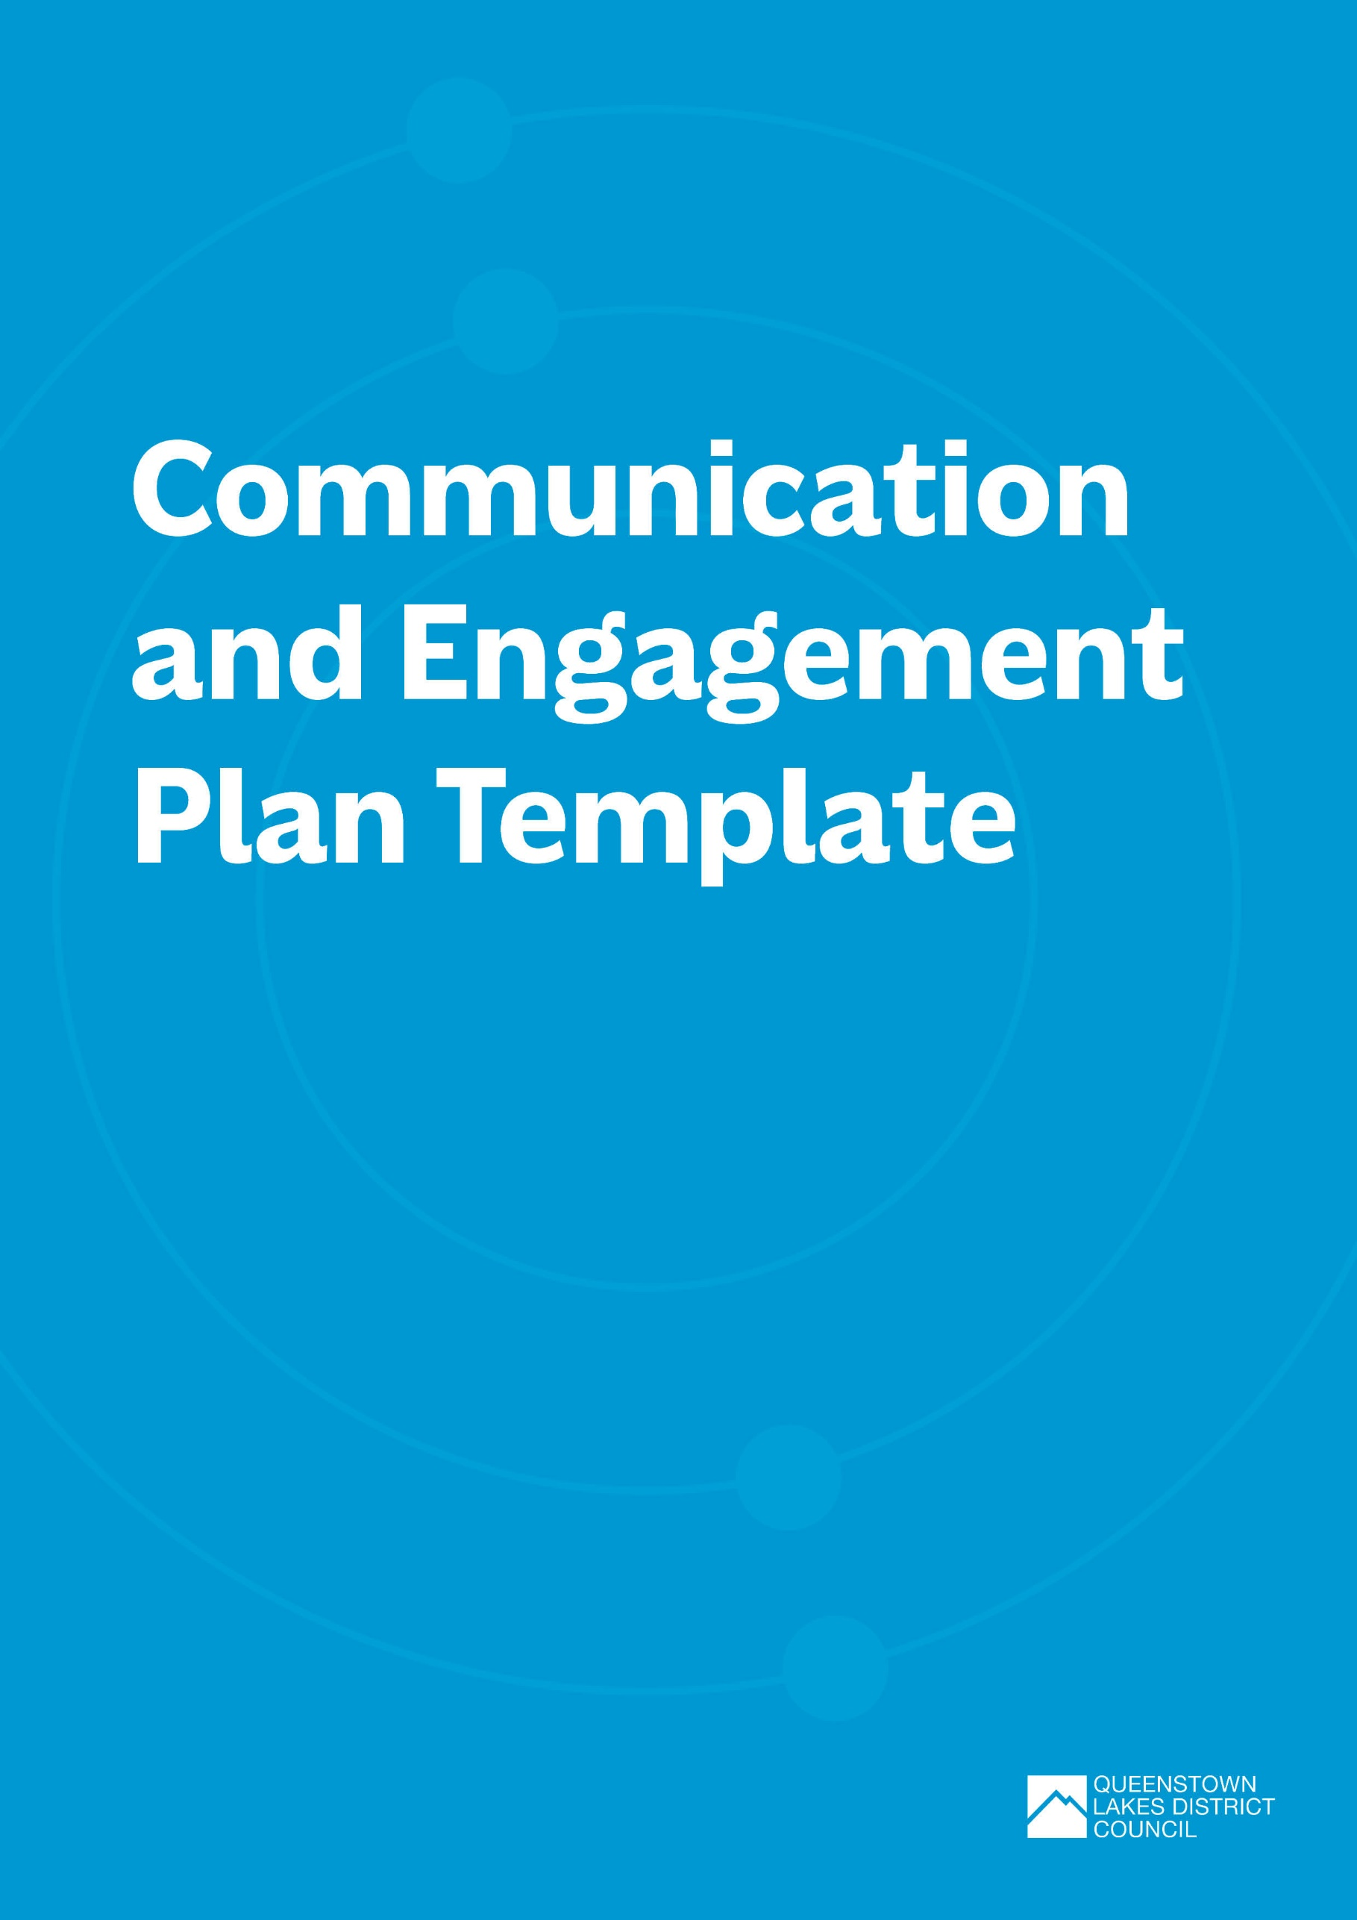

Communication and Engagement Plan Template
Use this template to plan effective strategies to raise awareness of your waste and emissions reduction initiatives before, during and after your event.

Key contacts
Note down the key people responsible for developing, implementing, and measuring the success of your communications and engagement plan.
Role | Responsibility | Contact Name | Contact email
E.g., Comms Manager | Development of communications and engagement plan.  Media liaison. | Tom Jones | Tom@eventcomms.com

WHAT ARE YOUr COMMUNICATION objectives FOR THE EVENT?
Take some time to think about the waste and emissions goals and targets you are trying to achieve. This will help to develop your key objectives and messaging for the event.
- What are your waste and emissions reduction goals?
- What are your specific targets?
- What is interesting or different about your initiatives?
- Why is reducing waste and emissions important to you or your event?
- Are your objectives measurable?

Who are your stakeholders?
Identify the relevant people who will impact on waste and emissions reduction goals. These are the audiences you will target with your communication and engagement.
Stakeholder / Group | Benefits of involvement | Level of interest | Level of influence
Individuals or groups e.g., attendees, sponsors, vendors, contractors, media etc. | What are the benefits of involving this stakeholder? | Of the stakeholder High/Medium/Low | Inform, consult, involve, collaborate, empower

What are your key messages?
Summarise your key messages to be used across all communications. Note these may vary by stakeholder and phase of event. When developing your key messages consider:
- Clear and concise messaging about your goals.
- Emphasise collective responsibility.
- Highlighting the positive impact of participation.
- Call to action for stakeholders.
- Using active and simple language that can be easily understood or translated
Stakeholder | Key Messages
 | Before Event | During Event | After Event
E.g., Attendees/general public | E.g., BYO coffee cup to help us reduce waste at our event. | E.g., Receive a $0.50c discount when purchasing a coffee with your reusable cup. | E.g., You helped us save 200 single use coffee cups from landfill.

Strategies and Channels:
Identify the strategies and channels you will use to target the various stakeholders at all stages of the event:
Stakeholder | Strategies and channels |  |  | Task Assigned To
 | Before Event | During Event | After Event
E.g., Attendees/  general public | E.g., social media posts every week in lead-up to event.  Incorporate information about waste and emissions reduction into ticketing documentation. | E.g., post two updates on social media during the event.  Brief attendees about initiatives upon entry. | E.g., post results on social media one week after the event.  Ask attendees for feedback via a post event survey. | E.g., waste/event coordinator

Measurement and Evaluation:
How will you measure the success of your communications and engagement plan? E.g., surveys or feedback forms from stakeholders, social media reach statistics, etc.

Indicative costs/budget:
If relevant.

