Draft Government Policy Statement on land transport 2021 Submission – due Monday 11 May
Draft GPS Consultation Feedback Form

Strategic Direction (section 2/pages 13-25 of the draft GPS)
The Government is prioritising investment in four areas of the land transport system over the next ten years – these are referred to as strategic priorities and are listed below. The four strategic priorities will contribute to achieving the five outcomes of the Transport Outcomes Framework.

4. Do you agree these should be the strategic priorities for investment in land transport?
Safety – YES
Better travel options – YES
Improving freight connections – YES
Climate change – YES

5. Do you have any comments on the strategic direction of the GPS?
The strategic direction for the GPS has developed well from 2018, showing a generational improvement. QLDC are concerned however that the priority of ‘Better travel options’ removes the focus from active travel and public transport. A mode-neutral approach is supported in principle, however mode shift requires focussed support. This support will be partially provided through Mode Shift Plans but needs to be represented in strategic direction.

Principles for Investing (Section 3.2/pages 29-30 of the draft GPS)
The Government provides a dedicated fund (the National Land Transport Fund) to support its investments in the land transport system. The draft GPS guides how the National Land Transport Fund (NLTF), and funds from local government, will be invested in the land transport system to progress the four strategic priorities.
The draft GPS provides three Principles for Investing (that describe value for money) for the Waka Kotahi NZ Transport Agency (Waka Kotahi) and local government to apply to their decision-making about whether to fund land transport projects through the NLTF. These are:
- Alignment: investments that align with the strategic direction of the GPS
- Effectiveness: the extent to which a proposal for funding achieves the strategic priorities of the GPS
- Efficiency: investments that are both at the best cost and achieve the best possible outcome for the total cost of ownership.

6. Do you understand the value for money principles in the draft GPS? Yes/No
YES

7. Do you have any other comments to make on the Principles for Investing?
QLDC welcomes support for lead infrastructure, (Section 3.2) though it is unclear at this stage how this will be delivered.

Activity Classes (Section 3.4/pages 32-35 of the GPS)

The draft GPS allocates money from the NLTF to eleven activity classes. Activity classes signal how Waka Kotahi and local government should balance investment in the land transport system. The funding ranges have been calculated in a way that assumes sufficient funding for maintenance of the network and continuing existing services before implementing the GPS strategic direction.
Local councils’ funds can still be used for projects outside of the eleven classes, but the allocations of money from the NLTF in the draft GPS should achieve the desired outcomes of the draft GPS.
The draft GPS includes three new activity classes. These are:
- Road to Zero, which will target interventions that are key to achieving the target reductions in road deaths and serious injuries sought through the Road to Zero strategy.
- Rail network, to implement the draft New Zealand Rail Plan by funding the NLTF share of approved activities from the Rail Network Investment Programme.
- Coastal shipping, to give freight operators more choice for how they transport their freight, and improve the competitiveness and environmental sustainability of the domestic coastal shipping sector.

8. Do you agree that funding to support Road to Zero activities (such as safety infrastructure, road policing, and road safety promotion) should come from a single activity class? Yes/No

9. Do you agree that the GPS should fund maintenance and renewal of the rail freight network? Yes/No
YES

10. Do you agree that the GPS should fund coastal shipping? Yes/No
YES

The activity classes are set in a way that balances delivering the strategic priorities and maintaining the existing network. The funding allocations in the draft GPS are expected to utilise expected revenue. Allocating more funding to an activity class would require a decrease in funding for a different activity class, or additional revenue (i.e increases to fuel excise duties and/or road user charges).

11. Considering the information above, would you support increasing or decreasing the funding levels for any activity classes. Please indicate any changes in the table below

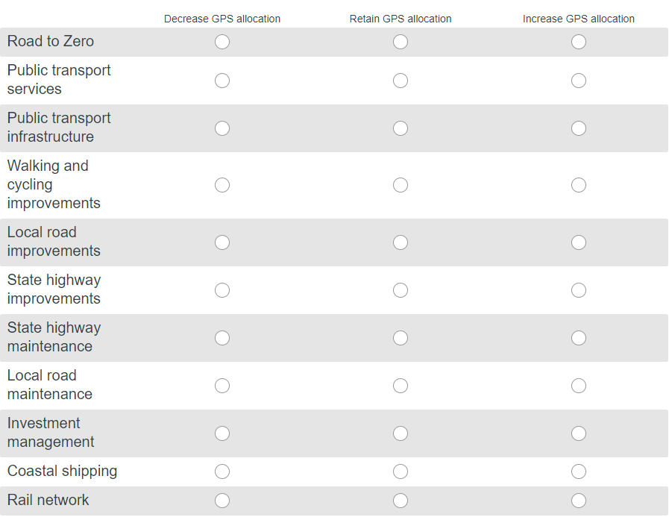

Increasing fuel excise duty (and equivalent road user charges) by one cent per litre generates around $50 million in revenue each year for the NLTF. The draft GPS does not propose an increase to fuel excise duty or road user charges for the next three years.
12. Would you support an increase to provide more funding to invest in any of the activity classes? Yes/No
YES

13. Do you have any other comments on the activity classes in the draft GPS 2021?
Walking and cycling improvements are central to active travel targets and therefore QLDC would support increases to the $1 billion allocated within the walking and cycling improvements category. This allocation amounts to only 10% of the public transportation and safety those budgets. There should also be a walking and cycling maintenance budget separated from the local road maintenance class as there are an increasing number of active travel assets from QLDC to maintain.
The separation of public transport into a ‘service’ class and an ‘infrastructure’ class risks the lack of integration between these two areas, already seen across many organisations.
Increased funding for policing and promotion (particularly automated enforcement), is supported, however this should be kept separate from safety infrastructure. The delivery and operation of infrastructure is very different to policing and promotion.

14. Do you have any other feedback on anything else in the draft GPS?
QLDC agrees that as per Q.9 the GPS should find maintenance and renewal of the rail freight network however this must not detract from the road portion of funding for areas where there is no rail network.
QLDC would like to see a follow-up report in light of COVID-19 with potential revenue and funding impacts, and whether there will be any changes to the priorities set prior to this event.
The indicators of a safer land transport network (Section 2.6) should include a measure of road safety through predictive risk.

15. Do any of your responses contain commercially sensitive information? Please select the question number(s) it’s included in:

Q5 - NO
Q7 - NO
Q13 - NO
Q14 - NO

Please explain why you think your response is commercially sensitive:
N/A

