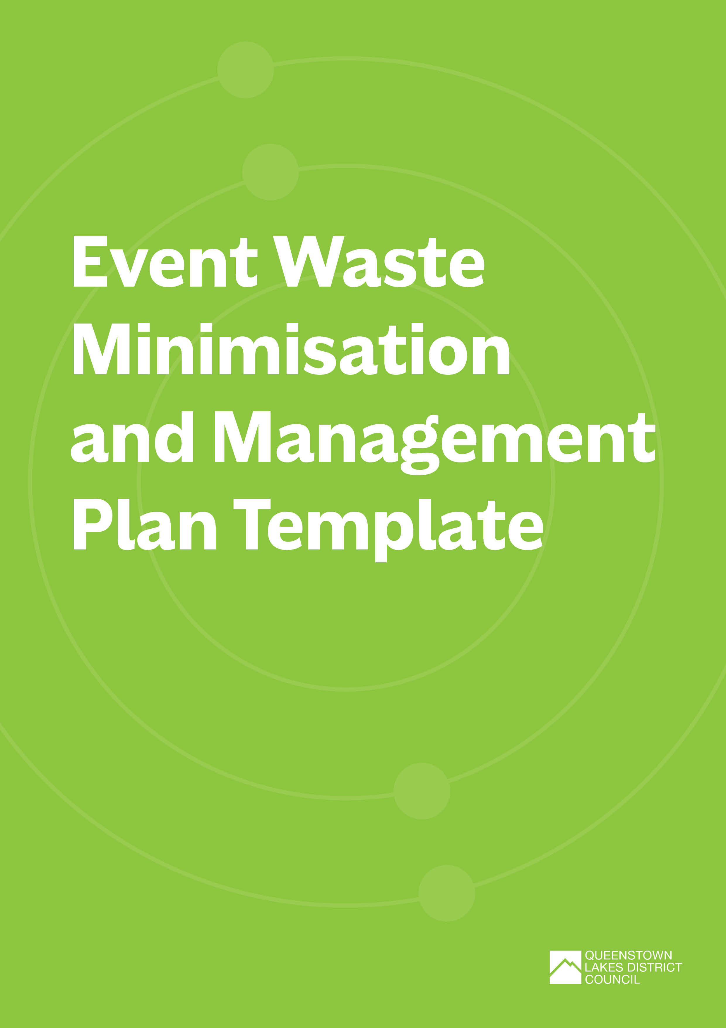

Event Waste Minimisation and Management Plan Template
Before you start, we encourage you to read through the Event Waste and Emissions Reduction Guide.
The template is broken up into three sections:
- Event overview
- Waste minimisation objectives, targets, success indicators and supporting initiatives
- Your event waste and infrastructure needs

How to use this template:
Complete each section below. You can add or remove rows in the tables as needed. We’ve provided some prompts and examples in greyed out text, just delete these as you work through your plan.
Please submit your completed plan and any supporting documents to our QLDC Waste Team via email: zerowaste@qldc.govt.nz

Event Overview
EVENT DETAILS
Event title: | Title of event/ official name of the event that will be referred to on any applications
Type of event: | E.g.:  - Arts / Cultural (Outdoor Exhibition or Performances)  - Entertainment (Music Festival, Circus, Concert)  - Community Event (School Fair / Gala Day, Fundraiser)  - Sports (Marathon, Cycle Race, Water Sports)  - Market (Craft Market, Food Market, Farmers Market)
Location (attach or insert map if possible): | Venue name, location and description
Date(s) of event: | Pack in:
 | Event start:
 | Event finish:
 | Pack out:
Estimated number of attendees:
Name of organisation delivering the event: | Lead organisation hosting the event
Event activities: | List the activities that will take place during the event. E.g., entertainment, music, performers, food and beverage, merchandise stall, marketplace, workshops, kids’ activities etc.
Number of food and beverage vendors:
Number of marketplace/ merchandise vendors:

Key contacts
Note down the key people responsible for developing, implementing, and measuring the success of your Event Waste Minimisation and Management Plan.
NAME/ ORGANISATION | ROLE | RESPONSIBILITY | PHONE | EMAIL
 | E.g., Waste Operations Manager | - developing the Event Waste Minimisation and Management Plan  - managing any necessary training for waste staff or volunteers  - liaising with waste collectors and service providers  - managing any volunteers helping with waste  - managing the reusables systems at your event (if applicable)  - managing the back of house waste hub  - capturing waste data and initiatives  - post event analysis and reporting.

Event waste PROFILE
List what kind of materials or waste will be generated by your event, the likely sources, and the timing. Outline which contractor you will be using to collect each material/waste stream and identify the end destination for each material/waste stream.
WASTE PROFILE
MATERIAL/  WASTE STREAM  GENERATED | SOURCE | TIMING – PRE, DURING, POST EVENT | COLLECTION CONTRACTOR (IF APPLICABLE) | WASTE/MATERIAL PROCESSOR DESTINATION
E.g., cardboard | E.g., exhibitors | E.g., pre-event/pack in | E.g., Wastebusters | E.g., Wastebusters
E.g., mixed recycling | E.g., front of house/attendees | E.g., during event | E.g., Smart Environmental | E.g., Wakatipu Recycling Centre
E.g., glass | E.g., bar | E.g., during event | E.g., Wastebusters | E.g., Wastebusters
E.g., food scraps | E.g., food vendors | E.g., during event | E.g., AllWaste | E.g., Central Wormworx
E.g., used cooking oil | E.g., food vendors | E.g., after event/pack out | E.g. Flower Power | E.g., Flower Power
E.g.; rubbish | E.g., front of house/attendees | E.g., during event | E.g., AllWaste | E.g., Frankton Transfer Station

Waste event objectives, targets, success indicators and initiatives
Now that you understand the event waste profile, list the objectives and targets you have identified to reduce it. Identify how you will measure success and what initiatives you will implement to achieve your objectives and targets.
OBJECTIVES | TARGET | HOW WILL YOU MEASURE SUCCESS? |  |  | INDICATORS FOR SUCCESS | SUPPORTING INITIATIVE
E.g., To reduce the amount of contamination in the recycling streams. | E.g., Less than 5% contamination in the mixed recycling and glass bins for year 2 of the event. | E.g., Conduct a waste audit and/or report end of event waste generation per stream. |  |  | E.g., Audit results show less than 5% contamination in the mixed recycling and glass bins. | E.g., Implement appropriate waste separation systems – front and back of house.  Bin monitoring and post event sorting.  Communication and engagement strategies, effective signage.
E.g., To reduce the amount of food scraps going to landfill. | E.g., 90% reduction in the amount of food waste disposed of in the landfill bin during the event in its first year. | E.g., Conduct a waste audit and/or report end of event waste generation per stream. |  |  | E.g., Audit results show that food waste has been re-directed to the compost bin rather than the landfill bin. | E.g., Implement compost collection bins for front and back of house.  Educate attendees via communication strategies and effective signage.
E.g.; To displace single use coffee cups. | E.g., No single use coffee cups used throughout event. | E.g., Conduct a waste audit and/or audit vendor serveware. |  |  | E.g., Audit results show no single use coffee cups in waste streams or being offered by vendors. | E.g., Integrating waste minimisation requirements into supplier/vendor agreements and work with vendors to implement reuse/loan cup system.  Encourage attendees to BYO reusable cup.
Approximately what percentage (%) of total waste do you hope to divert for this event by implementing the above objectives, targets, and initiatives? NOTE: Diversion rate is calculated by dividing the weight of diverted waste (e.g., your total recyclables) only by the weight of all waste generated. Multiply the amount by 100 to get your percentage (%). |  |  | %
Will you audit or do a post event sort of your waste streams? Undertaking an audit of your material/waste streams allows you to identify contamination and gather data to inform future minimisation initiatives. |  |  | ☐ | Yes
 |  |  | ☐ | No
If yes, please give details. |  |  | E.g., will the audit be on or offsite, who will conduct it?
If no, please provide detail on how you will measure and remove contamination in your waste streams.
Who are you using to help you implement your Waste Minimisation and Management Plan? Tick all that apply. |  |  | ☐ | Volunteers
 |  |  | ☐ | Paid Staff
 |  |  | ☐ | Contractors E.g., Wastebusters
 |  |  | ☐ | Other (please specify below)
Have you incorporated your waste minimisation objectives and requirements into your vendor agreements? |  |  | ☐ | Yes
 |  |  | ☐ | No
Will you be doing a vendor assessment? Refer to the Vendor Assessment Template provided. |  |  | ☐ | Yes
 |  |  | ☐ | No
What methods will you use to communicate your waste minimisation initiatives before, during and after your event? You can use the Communication and Engagement Plan Template as a guide.
Are there public rubbish and recycling bins on your event site? |  |  | ☐ | Yes
 |  |  | ☐ | No
If yes, please provide details on how you will avoid the use of these during your event e.g., reusable covers.
How will litter be collected and removed from public spaces within and around the event site, during and at the completion of your event?

EVENT Infrastructure
Use this table to plan what infrastructure is needed to support your waste minimisation objectives and targets.
WASTE INFRASTRUCTURE
TYPE | EXISTING OR REQUIRED? | QUANTITY | TIMING – PRE, DURING, POST EVENT | SUPPLIER | OVERSIGHT/ MANAGEMENT
Front of house
E.g., glass recycling bins | E.g., required | E.g., 10 x 140L bins with lids | E.g., during event | E.g., Wastebusters | E.g., the bins will be collected and replaced every 2 hours by Wastebusters staff
E.g., signage | E.g., existing | E.g., 20 x waste station feather flags | E.g., during event | E.g., Wastebusters | E.g., signage erected and monitored by Wastebusters staff
E.g., reusable serveware | E.g., required | E.g., 70 x plates, bowls and cups | E.g., during event | E.g., Sustainable Queenstown DISHrupt | E.g., crockery delivered and collected as required by DISHrupt staff
E.g., water refill trailer | E.g., required | E.g., 1 x QLDC water refill trailer | E.g., during event | E.g., QLDC | E.g., trailer set up and monitored by operations manager
Back of house
E.g., cardboard skip | E.g., required | E.g., 1 x 3m3 skip | E.g., during event and post event | E.g., AllWaste | E.g., skip will be collected at the end of the event
E.g., commercial dish wash station | E.g., existing | E.g., 1 x wash station | E.g., during event and post event | E.g., venue | E.g., crockery washed as required by DISHrupt staff
E.g., onsite waste sorting hub | E.g., required | E.g., 1 x marquee, 2 x trestle table, 1 x scale | E.g., during event and post event | E.g., Hire Pool | E.g., gear delivered by Hire Pool. Hub set up and co-ordinated by Wastebusters staff

If you are using reusable serveware at your event, please answer the following questions:
Where will reusable serveware be available during the event? | ☐ | At the point of sale with vendor/stallholder
 | ☐ | At designated collection point(s) – please specify:
 | ☐ | Other – please specify:
Will a bond system be used for reusable serveware? | ☐ | Yes
 | ☐ | No
 | ☐ | Other – please specify:
How will reusable serveware be collected after use? | ☐ | Returned to vendor/stallholder
 | ☐ | Designated drop-off point(s) - identify these on your site layout map.
 | ☐ | Other – please specify:
When and how will reusable serveware be washed and sterilised for reuse? Please specify:
- What equipment will be used
- If items will be rinsed/sterilised and reused during the event or washed after the event
- If this will be done on or off site
- Who and how many people will do this (volunteers or paid staff)

SITE LAYOUT
Once you have identified the infrastructure that you need, it’s a good idea to think carefully about where to put it on your event site.
Please provide a PDF file or insert an image of your site layout below. It should show where the waste infrastructure will be located (front of house and back of house) relative to event operations. Note, you may wish to produce more than one layout plan to show the location of infrastructure relevant to pack in, your live event, and your pack out operations.
SITE LAYOUT
At a minimum your site layout should include locations for:
- Waste stations including rubbish and recycling bins together
- Back of house waste hub, waste sorting, or storage facilities
- Signage
- Drinking water sites
- Drop off points for reusables
- Food/drink vendors and preparation areas
- Merchandise/market vendors
- Entertainment sites/stage location
- Entrances and exits
- Toilets and toilet blocks
- Any QLDC public rubbish and recycling bins
- The route collection vehicles will use to access the waste storage facilities during the event, if applicable

Funding
Queenstown Lakes District Council has various funding options to help with your event waste minimisation initiatives. Visit www.qldc.govt.nz/community/community-funding for more information.

Additional support
For further information or assistance with your Event Waste Minimisation and Management Plan, please contact the Queenstown Lakes District Council at

